Project Title | RecycleVision- Garbage Image Classification Using Deep Learning
Skills take away From This Project | Python Scripting, Deep Learning (CNN), Image Preprocessing & Augmentation, Transfer Learning, Evaluation Metrics, Streamlit App Development
Domain | Waste Management, Environmental Tech, Deep Learning, Computer Vision
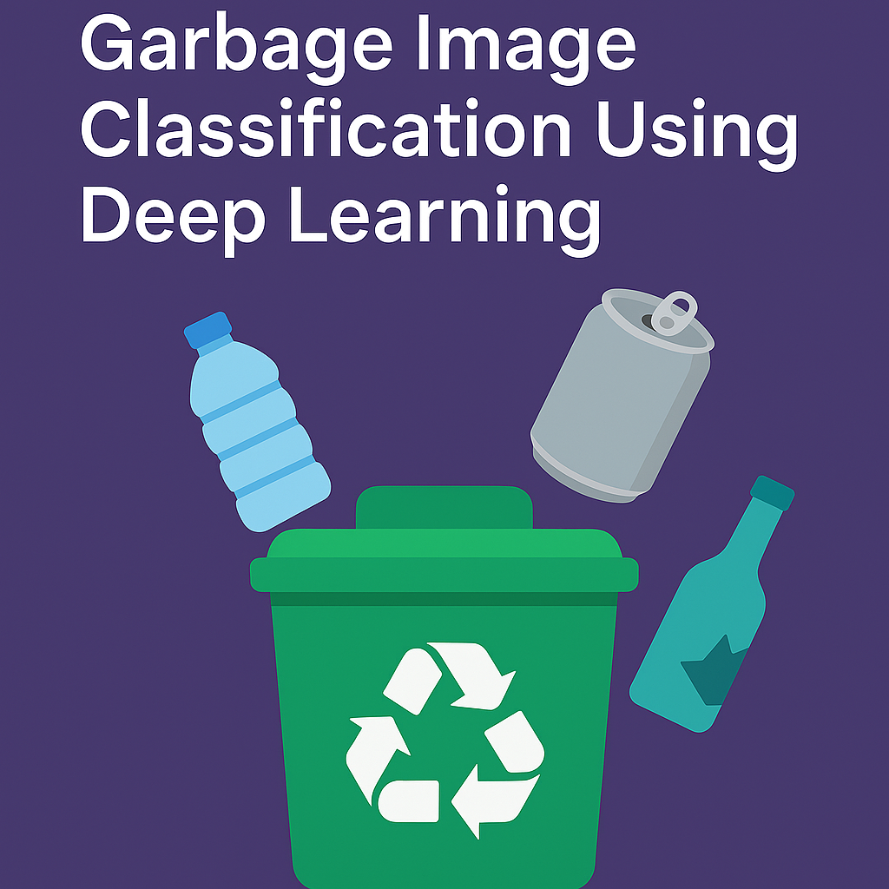
Problem Statement
Build a deep learning model that classifies images of waste into categories like plastic, metal, glass, paper, and organic. This system will assist in automating recycling by sorting garbage based on image input, using a deep learning model deployed via a simple user interface.
Business Use Cases
- Smart Recycling Bins: Automatically sort waste into appropriate bins.
- Municipal Waste Management: Reduce manual sorting time and labor.
- Educational Tools: Teach proper segregation through visual tools.
- Environmental Analytics: Track waste composition and recycling trends.

Approach

1. Data Preparation
- Use the TrashNet or Garbage Classification Dataset from Kaggle.
- Classes include: plastic, metal, glass, cardboard, paper, organic.

2. Data Cleaning & Preprocessing
- Resize all images (e.g., to 224x224).
- Normalize pixel values.
- Augment images with rotation, flipping, zoom, etc.
- Address class imbalance if present.

3. Exploratory Data Analysis (EDA)
- Visualize number of images per class.
- Show example images from each category.
- Analyze pixel intensity or color distribution.

4. Model Development
- Use Transfer Learning: ResNet50, MobileNetV2, or EfficientNetB0, etc.
- Freeze base layers; add custom dense layers for classification.

5. Model Evaluation
- Metrics: Accuracy, Precision, Recall, F1-Score, Confusion Matrix.
- Visualize misclassifications using a confusion matrix.

6. Best Model Selection
- Pick the model with the highest F1-score and balanced performance.

7. Application Development
- Create a Streamlit app with:
  - Upload feature for garbage images.
  - Predict and display waste category with confidence score.
  - Show top-3 predictions (optional).

8. Deployment
- Deploy app using Streamlit Cloud or run locally.

Data Flow and Architecture
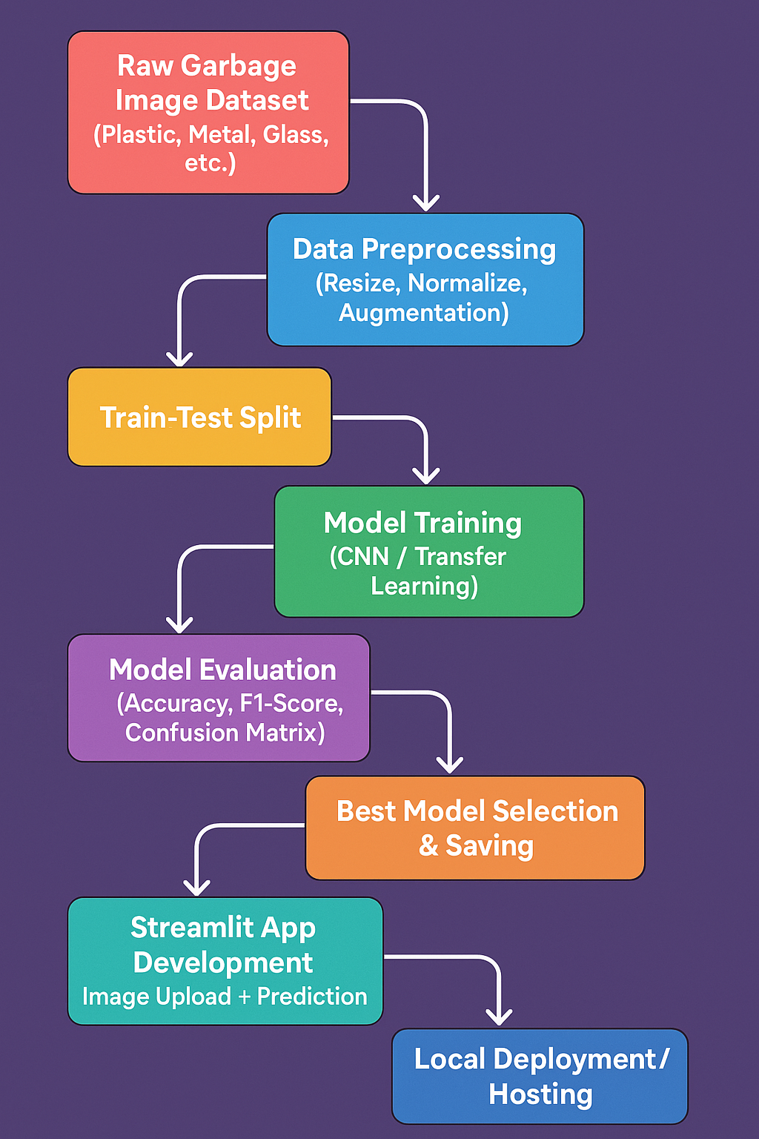
Dataset and Dataset Explanation:
- Garbage Classification (6 Classes)
- Description: This dataset contains images categorized into six classes: cardboard, glass, metal, paper, plastic, and trash.
- Size: Approximately 2,467 images.
- Link: Kaggle

- Garbage Classification (12 Classes)
- Description: An expanded dataset with 12 classes, including paper, cardboard, biological, metal, plastic, green-glass, brown-glass, white-glass, batteries, clothes, shoes, and trash.
- Size: Approximately 15,150 images.
- Link: Kaggle
- Garbage Classification V2 (10 Classes)
- Description: This dataset offers images categorized into 10 classes, designed for machine learning and computer vision projects focusing on recycling.
- Link: Kaggle
Note: you can use any one of these datasets for this project.
Results
- Preprocessed, augmented dataset
- Multiple deep learning models trained and evaluated
- Final app with high-accuracy waste category prediction
- Accessible UI using Streamlit

Project Evaluation Metrics:

Aspect | Evaluation Criteria
Data Preprocessing Quality | Proper cleaning, augmentation, and balanced class distribution
Model Performance | Accuracy > 85%, balanced precision/recall, low false positives
Confusion Matrix Analysis | Clear class-wise separation, minimal misclassification
User Interface | Functional and user-friendly Streamlit UI
Code Quality | Modular, reusable, well-documented Python scripts
Efficiency | Fast inference time and reasonable model size for deployment

Technical Tags:
Python, Deep Learning, CNN, TensorFlow, Keras, Image Classification, Transfer Learning, Computer Vision, Waste Management, Streamlit
Deliverables:
- Cleaned & Labeled Dataset
  - Garbage images categorized by type (plastic, metal, glass, paper, etc.)
- Preprocessing Pipeline
  - Scripts for image resizing, normalization, and augmentation
- Trained Deep Learning Models
  - Baseline CNN and Transfer Learning models (MobileNetV2, EfficientNetB0, etc.)
- Model Evaluation Report
  - Performance comparison table using metrics: Accuracy, Precision, Recall, F1-Score, Confusion Matrix
- Streamlit App
  - Interactive UI to upload and classify images with prediction labels
- Documentation
  - Step-by-step explanation of data handling, model training, and app deployment

Timeline:
- 1-2 Weeks
References:

Project Live Evaluation Metrics | Project Live Evaluation
EDA Guide | Exploratory Data Analysis (EDA) Guide
Capstone Explanation Guideline | Capstone Explanation Guideline
GitHub Reference | How to Use GitHub.pptx
Streamlit recordings (English) | Special session for STREAMLIT(11/08/2024)
Streamlit documentation | Install Streamlit
Project orientation (English) | POS : RecycleVision- Garbage Image Classification Using Deep Learning
Project Excellence Series[Deep learning] (Tamil) | Project Excellence Series: Guided Learning & Problem Solving [Deep Learning](Tamil)
Project Excellence Series[Deep learning] (English) | Project Excellence Series: Guided Learning & Problem Solving [Deep Learning](English)

PROJECT DOUBT CLARIFICATION SESSION ( PROJECT AND CLASS DOUBTS)

About Session: The Project Doubt Clarification Session is a helpful resource for resolving questions and concerns about projects and class topics. It provides support in understanding project requirements, addressing code issues, and clarifying class concepts. The session aims to enhance comprehension and provide guidance to overcome challenges effectively.
Note: Book the slot at least before 12:00 Pm on the same day

Timing: Monday-Friday (3:00PM to 4:00PM)
Saturday (2:00 PM to 3:00 PM)
Session link :
Project Doubt Session [DS/AIML]

LIVE EVALUATION SESSION (CAPSTONE AND FINAL PROJECT)

About Session: The Live Evaluation Session for Capstone and Final Projects allows participants to showcase their projects and receive real-time feedback for improvement. It assesses project quality and provides an opportunity for discussion and evaluation.
Note: This form will Open only on Saturday (after 2 PM ) and Sunday on Every Week

Timing:
For DS and AIML
Monday-Friday (11:00AM to 12:00PM) and (05:00PM to 06:00PM)
Saturday (11:00AM to 12:00PM)

Booking link : https://forms.gle/1m2Gsro41fLtZurRA

Evaluation Metrics : Project Live Evaluation

Project Created By | Verified By | Approved By
Vinodhini | Nehlath | Nehlath

